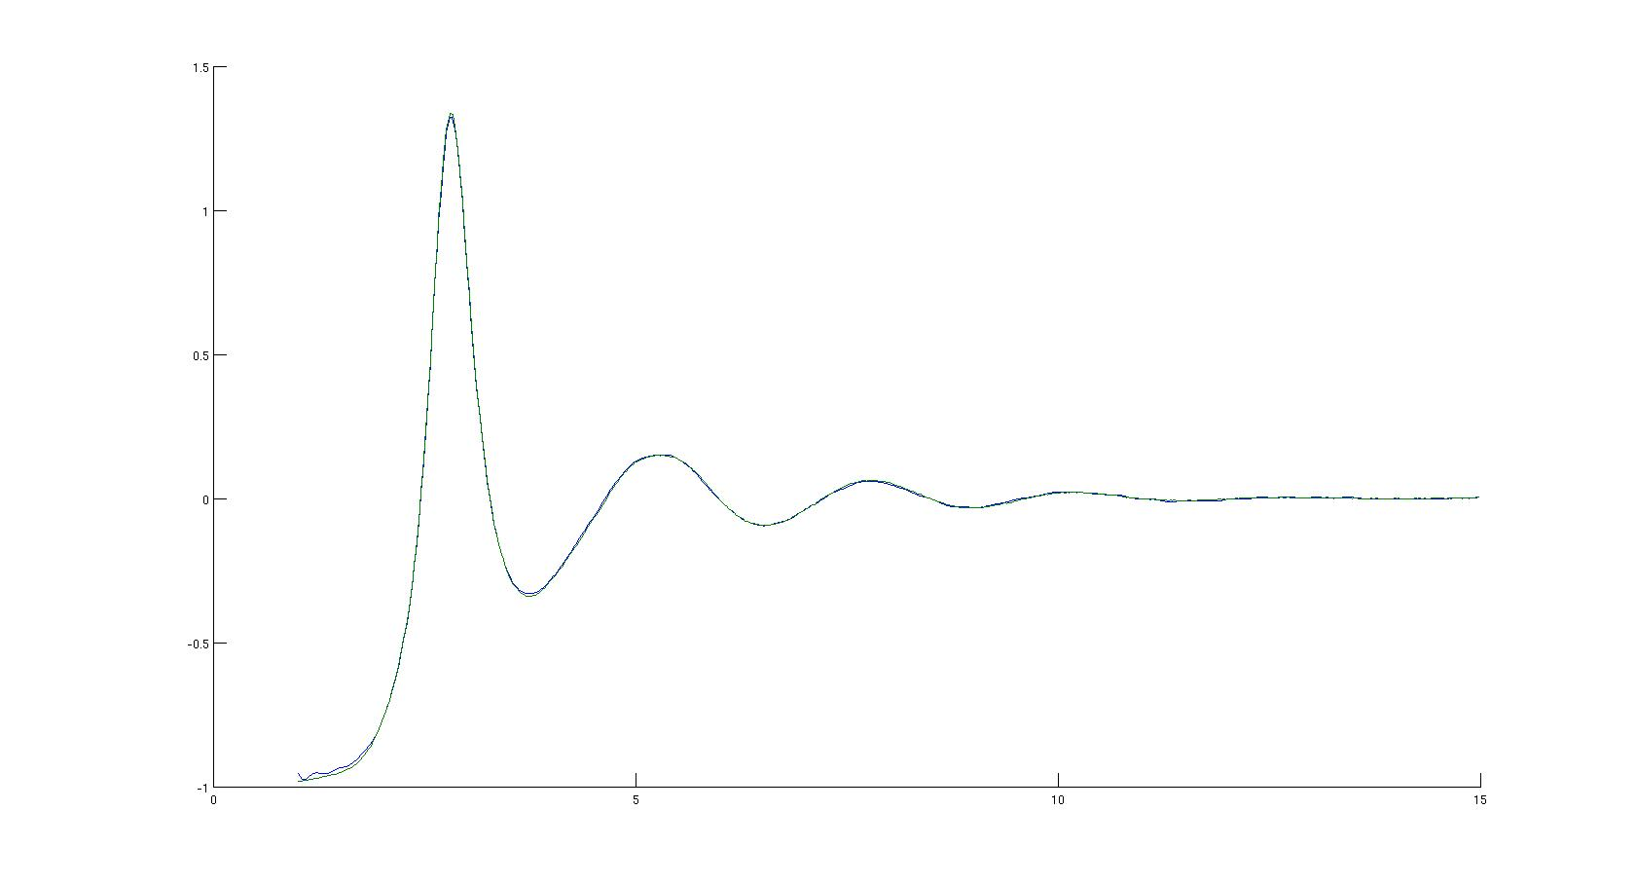
1175 C
Number of moves generated, Metropolis-tried, accepted sofar:
7898095, 7512795, 3097555
Average ratios tried/generated , accepted/tried over the last 2959 moves:
0.96 0.41
Global chi-squared value (per data point):1.147737e+00
.06376 number density

